|  |  |
| --- | --- |
| http://compsci.appstate.edu/sites/compsci.appstate.edu/files/imagecache/slideshow/slideshow/ASU_compsci_logo.png  **The CS4ALL NSF Supported Program** | https://encrypted-tbn3.gstatic.com/images?q=tbn:ANd9GcQGzOU-XT8XZWIBUwiPs2jjgixLO3CvrEyNq90lu1dbXJ0BQume  [**https://cs.appstate.edu/cs4all/**](https://cs.appstate.edu/cs4all/) |

**Subject Area**: Discrete Math

**Computer Science Tools:** SNAP

**Activity Title: Order requirement digraphs using SNAP Programming**

**Grade Level:** 8th and 12th

**Time Required:** 90 minutes

**Recommended Group Size:** 1 or 2

**Summary:** In this activity students will use beginning SNAP programming to understand the process of constructing an order requirement digraph and finding the critical path in Discrete Math.

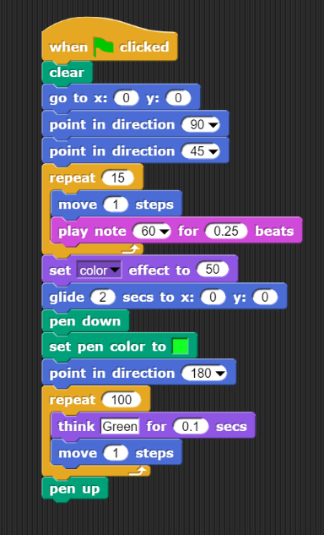**Computer Science Connection:** Introduction to programming logic

**Keywords:** Discrete, SNAP, Digraphs, Critical Path, List Processing

**Pre-Requisite Knowledge:** Complete a beginning SNAP tutorial

**Learning Objectives:** Students will be able to distinguish between dependent and independent tasks in an order requirement digraph.

**Materials List:** Computers with an internet connection and a web browser that supports SNAP.

**Background:** Class discussion about order requirement digraphs.

**Preparation:** Make sure you can access SNAP from: <https://snap.berkeley.edu/snap/snap.html>

One Possible Solution to the Lab Activity