**Pre-Assessment**  Name: ____________________

1. What are some of the properties of a square?
2. What are some of the properties of a circle?
3. What is an interior angle and exterior angle? What is the sum interior and exterior angles?

**Goals:**

1. Gain an introductory knowledge of SNAP and its programming concepts
2. Draw a square in the program
3. Draw an equilateral triangle in the program
4. Draw a circle in the program

**GOAL 1: Gain an introductory knowledge of SNAP and its programming concepts**

1. Open the program SNAP by going to <https://snap.berkeley.edu/snap/snap.html>
2. The gray arrow shape you see is called a Sprite, you are able to control its behavior and appearance using the colored options near the top left of the screen.
   1. 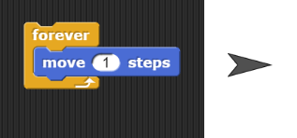Make your Sprite move 40 steps
      1. Drag and drop the “Move __ Steps” into the

programing area (Scripts tab)

* + 1. Change the “10” to a “40” then double click on the action

Sprite

* 1. Make your sprite move 1 step forever
     1. Change the “40” to “1”
     2. Go to the Control tab, drag the Forever loop into the programming area
     3. Place the “Move 1 Step” into the Forever loop. Double click the action
  2. Make your Sprite grow in size by 10 and then move 1 step forever
     1. This should make our Sprite get a little bit bigger once and then move as it did before
     2. Go to the Looks tab and place the “change size by 10” inside your Forever loop. Double Click.
     3. What happened? Was it what you had expected?
     4. To get your Sprite to the original size

1. Go to the Looks tab Find “Set size to ______%” and insert 100, then double click the action
   * 1. How should you change the code so our Sprite only grows one time?
2. To customize the Sprite 4. To customize the background
   1. Click on Sprite1, then Costumes
   2. Import
   3. Find the Sprite that fits you best
3. Click stage, then background
4. Paint your background a solid color of your choice

**Goal 2: Draw a square in the program with side length 70**

1. Click on Sprite 1. Clear the programming area by dragging the actions off to the left
2. The sides are 70 so have the Sprite move 70 steps
3. The sprite then needs to turn 90 degrees, use “Turn 90 degrees” right or left
4. We want 4 sides, so let’s use a “Repeat 4 ” loop from the Control tab
5. Run your code.
6. It appeared to move in the shape of a square, but we wanted to DRAW a square
7. Go to the Pen tab and place “pen down” above the Repeat loop to make your Sprite actually draw the square

**Goal 3: Draw an equilateral triangle**

1. What do you know about the sides of an equilateral triangle?
2. What do you know about the angles of an equilateral triangle?
3. Using a similar code process, draw an equilateral triangle.
   * 1. Sides must be 40 steps
     2. To erase the squares, go to

Pen then “Clear”

* + 1. The angle you turn needs to be the exterior angle.

1. Write the code here:

**Goal 4: Draw a circle**

1. How many 30° exterior turns would we need to make a circle?
2. Write the code to make that circle (move forward 40 steps each time)
3. How can we make it better?
4. What is the code for your new circle?

**Post-Assessment**

1. 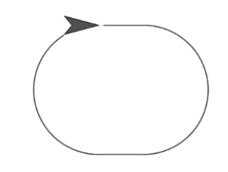Draw a running track. What is the code?
2. Draw a figure 8. What is the code?

