|  |  |
| --- | --- |
| http://compsci.appstate.edu/sites/compsci.appstate.edu/files/imagecache/slideshow/slideshow/ASU_compsci_logo.png  **The CS4ALL NSF Supported Program** | https://encrypted-tbn3.gstatic.com/images?q=tbn:ANd9GcQGzOU-XT8XZWIBUwiPs2jjgixLO3CvrEyNq90lu1dbXJ0BQume  [**https://cs.appstate.edu/cs4all/**](https://cs.appstate.edu/cs4all/) |

**Activity Title:** Introducing Programming with SNAP

**Materials List:** Access SNAP from <https://snap.berkeley.edu/snap/snap.html>

**Introduction/Motivation:** SNAP is a software development tool that is fun to use. It uses object-oriented programming to move characters (sprites). It introduces students to the process of thinking logically through a process and then creating the algorithm. A drag-and-drop arena aids in the quickness of developing a program in SNAP. Students can quickly master their first programs fostering confidence in the ability to program.

**Procedure:**

**Background:** A secret to programming is logically thinking through the process. We will be using pseudocode to think through our program. Pseudocode is a listing of steps in more or less natural language to ensure that the process has been logically designed. You will begin with a statement of the problem (movement of sprites on the screen) then write the pseudocode instructions.

*Problem:*You need to add two new sprites. One that looks like a ball and one that looks like a cat. The ball will be thrown from off-screen on the right to the cat on-screen on the left. When the cat “catches” the ball, it will make a “meow” sound. The cat will then throw the ball back. The ball needs to travel at a pace that it can be seen moving.

*Pseudocode for the example problem:*

* Before writing the program, add a ball and a cat sprite
  + To run the program, click the green flag
  + Move cat to the left edge (-191,-4)
  + Tell ball to move
  + Move ball to the right edge (248, 11)
  + Ball moves for 10 seconds to the cat
  + When ball touches cat, meow sound
  + Wait for a second
  + Tell ball to move
  + Ball moves for 10 seconds back to the right edge

**Preparation:** SNAP may be accessed at <https://snap.berkeley.edu/snap/snap.html>

**Lab Activity:**

1. Go to <https://snap.berkeley.edu/snap/snap.html> and Try It Out.
2. 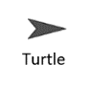You will need two sprites so add a new basic Turtle sprite by clicking the “add a new Turtle sprite button” (see Figure 1).
3. Now click the file button in the top left corner and select “Costumes…” A window will pop up with costume options. Scroll thru until you find a ball and select it (see Figure 2).
4. Now go to the bottom right and select the sprite that is still a basic Turtle and then do the same process to change it to a cat.

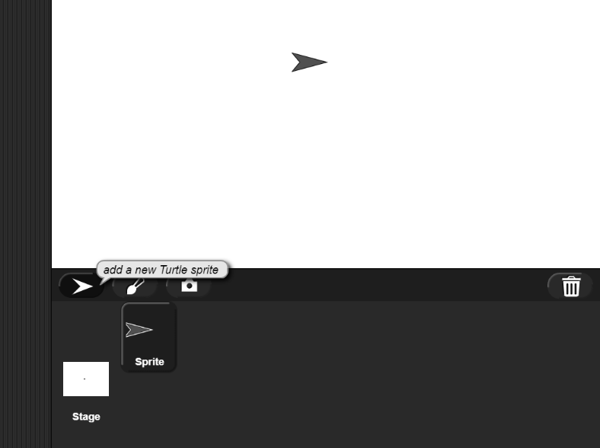

Figure 1: Creating a new basic Turtle sprite

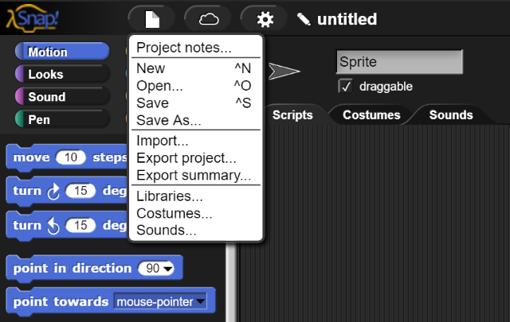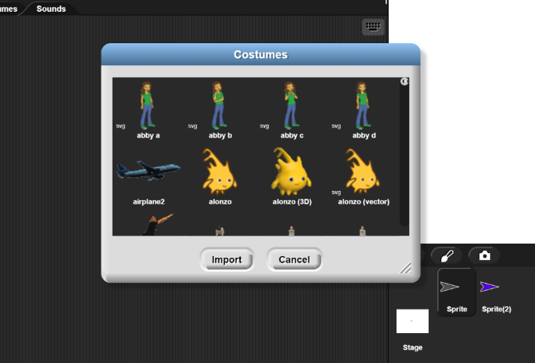

Figure 2: Changing costumes

1. You should now have 2 sprites and one should be a cat and the other a ball.
2. Click the cat in the bottom right panel.
3. Go to Control (top left corner). Drag “when  clicked” to the Scripts panel. (Note: if you drag the wrong command or decide not to use one, simply drag it back.)
4. Position the cat by dragging the “go to x: y” command from the Motion tab and attaching it to the “when clicked”. Set x: to -191 and y: to -4 (see Figure 3).

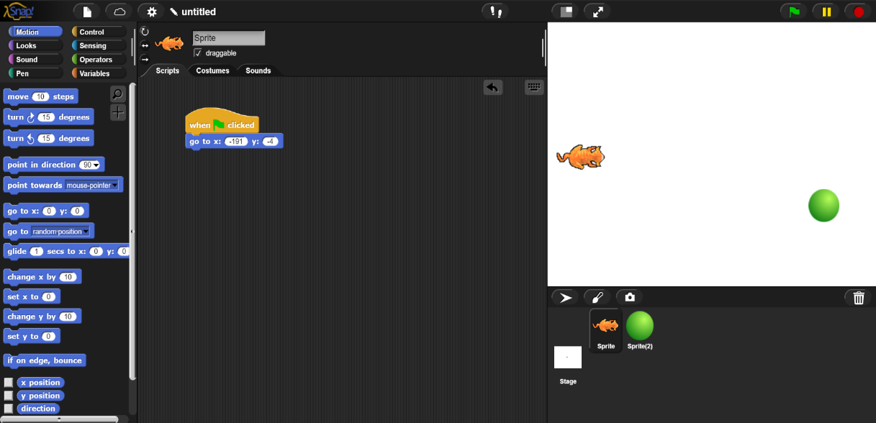

Figure 3: Adding your first commands

1. From the Control, drag “when I receive ” to the Scripts pane.
2. Click the dropdown arrow and select “new…”. In the message name dialog box type “catch”. You are telling the cat that it will receive this message from the ball.
3. Go to the file button just like you did for the costumes and select “sounds…” and then select and import a meow sound from the window that pops up
4. Now your scripts tab will have changed to the Sounds tab so go back into the scripts tab
5. Go to the Sound (the one under Looks, not the one next to Costumes) and drag “play sound ” and attach to the “when I receive ” command.
6. Click the dropdown arrow and select the meow sound that you imported
7. Go to Control and drag “wait 1 secs” and attach to “play sound” command.
8. From the Control drag “broadcast  ” and attach to “wait” command.
9. Click the dropdown arrow and select “new…”. In the message name dialog box type “throw”.
10. Your Scripts pane for the cat sprite should look like Figure 4.

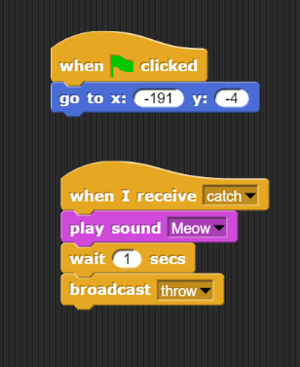

Figure 4: Scripts for Cat Sprite

1. Select the ball sprite in the bottom right.
2. Go to Control. Drag “when clicked” to the Scripts panel.
3. Position the ball by dragging the “go to x: y” command from Motion and attaching it to the “when clicked”. Set x: to 265 and y: to 11.
4. Drag the “glide 1 secs to x: y: command and attach to the “go to” command.
5. Modify the glide to 10 secs, X: -172, and y: -30.
6. Attach the “broadcast ” command from Control to the “glide” command.
7. Use the dropdown arrow to select “catch”. This is the message that you are expecting in step 10.
8. Drag the “when I receive ” command to the Scripts pane.
9. Use the dropdown arrow to select “throw”.
10. Drag the “glide 1 secs to x: y: command Motion and attach to the “when I receive” command.
11. Modify the glide to 10 secs, X: 248, and y: 11.
12. Your Scripts pane for the ball sprite should look like Figure 5.

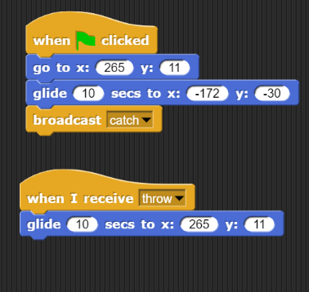

Figure 5: Scripts for the Ball Sprite

1. Click to start your program.
2. The ball is slow. Modify its glide speed to 3 seconds each way and run the program again.
3. Click on the file button and Save your project as Catch to submit later.
4. You need to create a program based on the following problem.

*Problem:* You need a ball sprite. Throw the ball from the upper middle of the edge of the screen. In the middle of the screen, your ball hits a flat object. It is deflected back at the proper angle.

1. Type the pseudocode into a word processor (save it) before working in SNAP.
2. Create the SNAP program. Make any necessary adjustments and note them in the pseudocode document.
3. Save the program with an appropriate name.
4. Submit both programs and your pseudocode.

**Assessment**

* + Follow instructions to create a program in SNAP.
  + Create appropriate pseudocode.
  + Create own program in SNAP based on the pseudocode.
  + Calculate angle of deflection.