|  |  |
| --- | --- |
| http://compsci.appstate.edu/sites/compsci.appstate.edu/files/imagecache/slideshow/slideshow/ASU_compsci_logo.png  **The CS4ALL NSF Supported Program** | https://encrypted-tbn3.gstatic.com/images?q=tbn:ANd9GcQGzOU-XT8XZWIBUwiPs2jjgixLO3CvrEyNq90lu1dbXJ0BQume  [**https://cs.appstate.edu/cs4all/**](https://cs.appstate.edu/cs4all/) |

**Subject Area(s):** Object-based Programming, Mathematics

**Computer Science Tools:** SNAP

**Activity Title:** SNAP Calculator

**Grade Level:** 9th+

**Time Required:** 1.5 hours

**Recommended Group Size:** 1

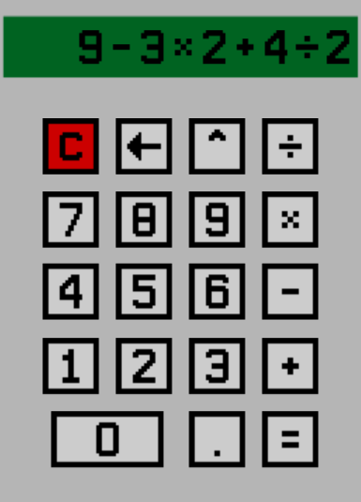**Summary:** Students are required to build a functional four operation calculator by using SNAP. The goal is to become familiar with handling input/output functions as well as the mathematical functions in SNAP. ***There may be several existing calculators on the SNAP webpage but students should be making their own.*** For added complexity, more advanced students could be required to include other operations and functions (e.g. square root, powers, and trigonometric functions).

**Computer Science Connection:** Programming and logic

**Keywords:** SNAP, object oriented, programming, logic, math, calculator

**Pre-Requisite Knowledge:** Programming Logic, Familiarity with SNAP

**Materials List:**

* Access SNAP from: <https://snap.berkeley.edu/snap/snap.html>

Teacher Only

* SNAP calculator examples

**Introduction/Motivation:** This module is designed to introduce students to some of the input and output operations and mathematical functions that come prepackaged in SNAP. This module is a stepping stone between introductory SNAP modules and more advanced modules like the Projectile Motion simulator.

**Assessment (Results/Conclusions)**

* + Build a full working program that handles +, -, *, / operations.
  + Build a full working program that handles the above operations as well as square root, powers, and trigonometric functions.