|  |  |
| --- | --- |
| http://compsci.appstate.edu/sites/compsci.appstate.edu/files/imagecache/slideshow/slideshow/ASU_compsci_logo.png  **The CS4ALL NSF Supported Program** | https://encrypted-tbn3.gstatic.com/images?q=tbn:ANd9GcQGzOU-XT8XZWIBUwiPs2jjgixLO3CvrEyNq90lu1dbXJ0BQume  [**https://cs.appstate.edu/cs4all/**](https://cs.appstate.edu/cs4all/) |

**Activity Title: Probability Using SNAP**

**Introduction/Motivation:**

Probability is a measure of how likely an event is to occur. The probability of an event occurring is the ratio of the number of favorable outcomes to the number of possible outcomes. In this activity, students are expected to conduct an experimental probability and simulation using SNAP program to find the probability of simple and compound events and to distinguish the difference between dependent and independent probability. Also, they are expected to evaluate the validity of a statistical model.

**Materials:**

Physical Dice

SNAP program “SingleDieSimulator.xml”

SNAP program “TwoDiceSimulator.xml”

**Procedure:**

**Preparation:**

Provide one computer/laptop and dice for each student.

**Assessment**

**Pre-Assessment:**

* Define simple and compound events.
* Differentiate theoretical and experimental probability.
* Differentiate between dependent and independent probability.

**Lab activity**

Students will work in pairs and collaborate to perform this activity.

**Part 1A. Single Events Probability**

1. Write the theoretical probability of P (6) of a single die. P (6) =_________.
2. Next, do the experimental probability. Use the actual die and roll it 15 times to find the P(6).

Record your result on Table 1. What is the value of P (6) =_______?

Table 1

|  |  |  |  |
| --- | --- | --- | --- |
| # of roll | Result | # of roll | Result |
| 1 |  | 9 |  |
| 2 |  | 10 |  |
| 3 |  | 11 |  |
| 4 |  | 12 |  |
| 5 |  | 13 |  |
| 6 |  | 14 |  |
| 7 |  | 15 |  |
| 8 |  | P(6) = |  |

1. Compare the P (6) of theoretical and experimental probability. Can you tell if you roll a fair die? Explain.

**Part 1B. Single Events Probability**

1. Open the SNAP program “SingleDieSimulator.xml”

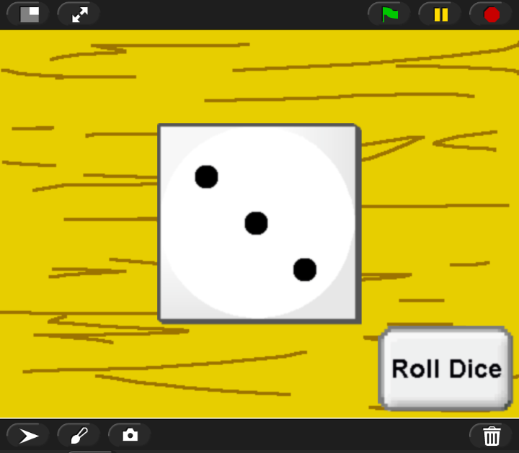

1. Click the green flag to start the simulation. Click “Roll Dice” to roll the die.
2. Find P (6) by rolling the die 15 times and record your result on Table 2.

Table 2

|  |  |  |  |
| --- | --- | --- | --- |
| # of Roll | Result | # of Roll | Result |
| 1 |  | 9 |  |
| 2 |  | 10 |  |
| 3 |  | 11 |  |
| 4 |  | 12 |  |
| 5 |  | 13 |  |
| 6 |  | 14 |  |
| 7 |  | 15 |  |
| 8 |  | P(6) |  |

1. Compare the results of P(6) of Table a and 2, can you tell if you rolled a fair die? Explain.

**Part 2 Compound Event Probability**

1. Open the SNAP program “TwoDiceSimulator.xml”

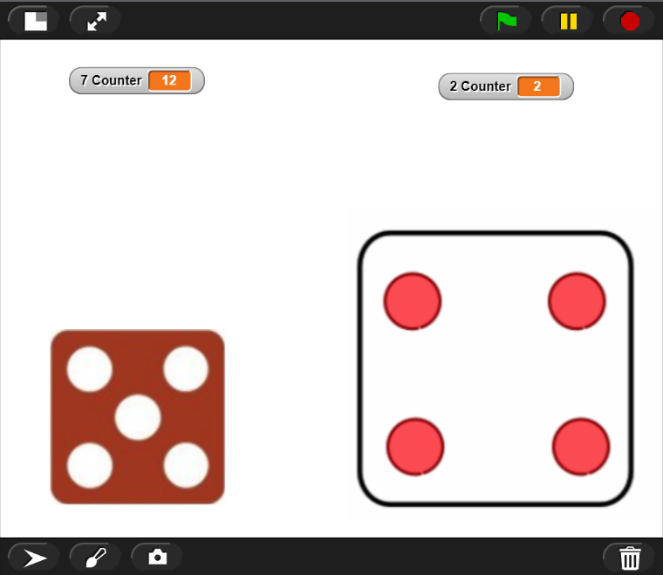

1. Click the green flag to start the simulation. Click “Roll Dice” to roll the dice. Both dice will be rolled simultaneously 100 times in a row. You can click the green flag to start over at any time and you can click the yellow pause button next to the green flag to pause the simulation at any time.
2. Trial#1: Use the simulator to complete the table below. Record your results on Table 3.

Table 3

|  |  |  |  |  |  |  |  |  |  |
| --- | --- | --- | --- | --- | --- | --- | --- | --- | --- |
| Sum of Dice | 2 | 3 | 4 | 5 | 6 | 7 | 8 | 9 | 10 11 12 |
| Outcome Tally |  |  |  |  |  |  |  |  |  |
| No.of Outcome |  |  |  |  |  |  |  |  |  |
| Probability |  |  |  |  |  |  |  |  |  |

1. Do the results from Table 3 show “independent” or “dependent” probability? Explain.
2. Trial # 2: Do two dice simulation again for the 2nd trial and record your result on Table 4.

Table 4

|  |  |  |  |  |  |  |  |  |  |
| --- | --- | --- | --- | --- | --- | --- | --- | --- | --- |
| Sum of Dice | 2 | 3 | 4 | 5 | 6 | 7 | 8 | 9 | 10 11 12 |
| Outcome Tally |  |  |  |  |  |  |  |  |  |
| No.of Outcome |  |  |  |  |  |  |  |  |  |
| Probability |  |  |  |  |  |  |  |  |  |

1. Compare the results of probability on Table 3 and 4. Write all your observations.
2. What is the probability of rolling back-to-back sixes? P (6, then 6) = _________________
3. What is the probability of rolling back-to-back evens? P (even, then even) =____________
4. What is the probability of P (even, then odd) =____________?

**Results/Conclusions:**

1. How do I find the probability of simple and compound events?
2. How can I distinguish between simple and compound events?
3. How I can evaluate the validity of a statistical model?

**References:**

NCDPI website:

http://maccss.ncdpi.wikispaces.net/file/view/MathII-UnpackedStandards-10.30.13.pdf/464653278/MathII-UnpackedStandards-10.30.13.pdf