|  |  |
| --- | --- |
| http://compsci.appstate.edu/sites/compsci.appstate.edu/files/imagecache/slideshow/slideshow/ASU_compsci_logo.png  **The CS4ALL NSF Supported Program** | https://encrypted-tbn3.gstatic.com/images?q=tbn:ANd9GcQGzOU-XT8XZWIBUwiPs2jjgixLO3CvrEyNq90lu1dbXJ0BQume  [**https://cs.appstate.edu/cs4all/**](https://cs.appstate.edu/cs4all/) |

**Activity Title:** “Genetic Inheritance Using SNAP”

**Summary:** In this activity, students use SNAP to work through a series of questions in order to visualize Punnett squares, Inheritance, in addition to genotype and phenotype ratios. The program gives examples of dominance vs recessive traits, incomplete dominance, and co dominance. This activity is to supplement a worksheet once Mendelian Genetics has been introduced and modeled.

**Preparation**:

1. Access SNAP from: <https://snap.berkeley.edu/snap/snap.html>
2. Then open the provided SNAP program titled “GeneticInheritance.xml”

**Lab Activity**:

**PART ONE**

1. Make the simulation full screen by clicking the full screen button  on the top right side.
2. Click the green flag  and begin!
3. 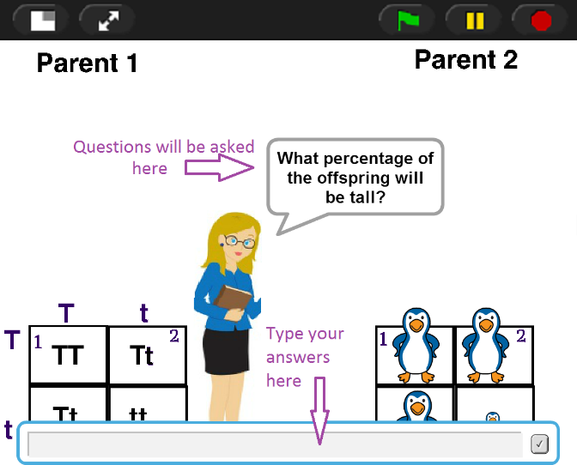When the teacher prompts you with a question, either click on the correct image, or write your answer in the text box that pops up at the bottom of the screen. When clicking on one of the images to answer a question, if the program does not respond, simply move the cursor over a different part of the image and try again.
4. Fill in the blank answers are case sensitive. If a student answers incorrectly a hint will be given to help guide them to the correct answers. ***\*\*Do not use commas or “and” when giving multiple answers. EX: AA Aa aa is correct NOT AA, Aa, and aa\*\****
5. Number your paper from 1-29, and write the correct answer on your own paper as you go through the program.

**PART TWO**

1. You and a partner will create your own SNAP program that simulates a Punnett Square cross. You may show any of the types of inheritance studied. You may not use any of the examples that are already in the program.
2. This simulation may be in whatever form you like! It can be a review game, a mini-movie or a study tool. Think about what would help you learn the material!
3. Be creative! Play with costumes and moving the sprite around.
4. If you need further assistance on how to write a SNAP simulation, feel free to look over the code for the program from Part One. Note that much of the code is stored in functions. Right click on a function and click edit to see inside.
5. When you are finished talk to your teacher about how they would like you to submit your SNAP project.

**Assessment**

Make sure you have thoroughly and correctly answered questions in Part One of this activity. These will be taken as a classwork grade. For Part Two, you will be assessed based on the quality of your work, scientific accuracy, and user friendliness.