|  |  |
| --- | --- |
| http://compsci.appstate.edu/sites/compsci.appstate.edu/files/imagecache/slideshow/slideshow/ASU_compsci_logo.png  **The CS4ALL NSF Supported Program** | https://encrypted-tbn3.gstatic.com/images?q=tbn:ANd9GcQGzOU-XT8XZWIBUwiPs2jjgixLO3CvrEyNq90lu1dbXJ0BQume  [**https://cs.appstate.edu/cs4all/**](https://cs.appstate.edu/cs4all/) |

**Activity Title: “Reinforcing Kinetic and Potential Energy with SNAP”**

**Materials List:**  Computer with internet access, calculator and SNAP program

**Introduction/Motivation:** Have you ever climbed a hill or a mountain? Have you ever wonder whether your Kinetic or Potential energy will change if you change your mass? In this activity, we are going to visualize potential and kinetic energy using the SNAP program

|  |  |  |
| --- | --- | --- |
| Formula | Abbreviations | Units of Measurements |
| PE = mgh | M = mass | Kilograms |
| G = Gravity = 9.8 m/s2 | Meters per second |
| H = Height | Meters |
| Potential Energy | Newton-meter or Joules (J) |
| KE = ½ mv2 | V = velocity | Meter/second |

**Background:** You should have the basic understanding of the calculation of Potential Energy and Kinetic Energy.

**Preparation:** Basic knowledge on SNAP programming.

**Procedure:**

Part A.

1. Access SNAP from <https://snap.berkeley.edu/snap/snap.html>
2. Click the file button  in the top left and select “Open…”
3. Now open the file entitled “PenguinEnergy.xml” that was provided by your teacher
4. Now click the Fullscreen button  in the top right
5. Next click on the green flag button  to start the simulation
6. Change the mass with the slider and observe the Potential energy of the Penguin

**Lab Activity 1:**

1. Click on the flag button  to see how the Penguin moves and observe the variables Potential Energy and Mass
2. Complete the following table: Wait until the moving penguin comes to a full stop

|  |  |
| --- | --- |
| **Mass**  **(Kg)** | **Potential Energy (J)** |
| 10 |  |
| 15 |  |
| 20 |  |
| 25 |  |
| 30 |  |

1. Answer the following questions:
2. What happens to the Potential energy when mass increases?
3. What happens to the Potential energy when mass decreases?

**Lab Activity 2:**

1. Now exit out of Fullscreen 
2. Create the Kinetic energy formula into the script, see picture below. Hint: Enter fraction as a decimal in the formula; there are 3 operators and 1 data command needed for the formula
3. Make a screen shot
4. Save it in your desktop
5. Click on the file button  and save the project

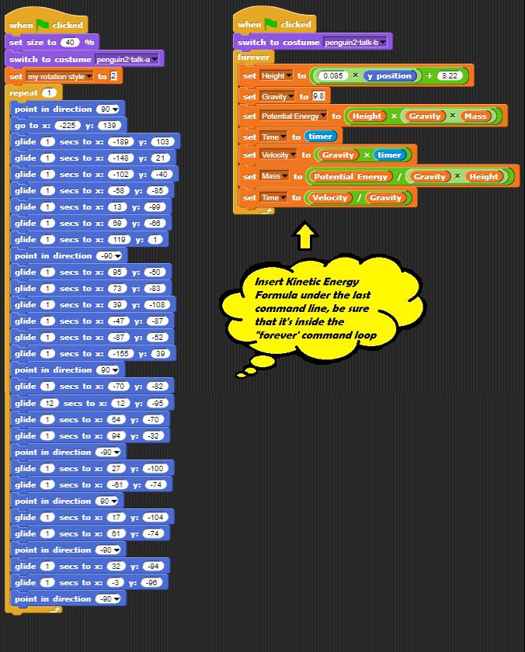

1. Click on the flag button  to see how the Penguin moves and observe the variables Kinetic Energy and Mass as the penguin stops
2. Now, complete the table below:

|  |  |
| --- | --- |
| **Mass**  **(Kg)** | **Kinetic Energy (J)** |
| 10 |  |
| 15 |  |
| 20 |  |
| 25 |  |
| 30 |  |

1. Answer the following questions:
2. What happens to Kinetic energy when mass increases?
3. What happens to Kinetic energy when mass decreases?

**Further Explorations: (For Bonus points)**

Manipulate the height of the moving penguin and see the difference in the Potential energy.

Fill up the table below based on the changes you made:

|  |  |  |
| --- | --- | --- |
| **Height** | **Potential Energy** | **Kinetic Energy** |
|  |  |  |
|  |  |  |
|  |  |  |
|  |  |  |