|  |  |
| --- | --- |
| http://compsci.appstate.edu/sites/compsci.appstate.edu/files/imagecache/slideshow/slideshow/ASU_compsci_logo.png  **The CS4ALL NSF Supported Program** | https://encrypted-tbn3.gstatic.com/images?q=tbn:ANd9GcQGzOU-XT8XZWIBUwiPs2jjgixLO3CvrEyNq90lu1dbXJ0BQume  [**https://cs.appstate.edu/cs4all/**](https://cs.appstate.edu/cs4all/) |

**Subject Area(s):** Physics, Physical Science

**Computer Science Tools:** Computer, SNAP Program

**Activity Title:** “Reinforcing Kinetic and Potential Energy with SNAP”

**Grade Level:** 9th

**Time Required:** 90 minutes

**Recommended Group Size:** individual work

**Summary:** In this activity, students will use SNAP programming to reinforce basic knowledge in Potential and Kinetic energy. Students will compare the effect, if any, when changing the mass, on the Potential and Kinetic energy. Students will have an opportunity to manipulate variables in SNAP to enter the formula in calculating the Kinetic energy of the sprite. Students will have the opportunity to visualize how the Kinetic and Potential energy change as the sprite moves around.

**Computer Science Connection:** Students will develop their Programming and Problem Solving abilities.

**Keywords:** mass, height, gravity, potential energy, kinetic energy, velocity, SNAP

**Pre-Requisite Knowledge:** Students should be familiar with Kinetic and Potential energy formulas and basic SNAP programming.

**Learning Objective:**

Students will use SNAP to find the Potential and Kinetic energy and determine its dependency on mass of the object.

**Materials List:**

* A Computer
* SNAP program accessed from <https://snap.berkeley.edu/snap/snap.html>
* A calculator

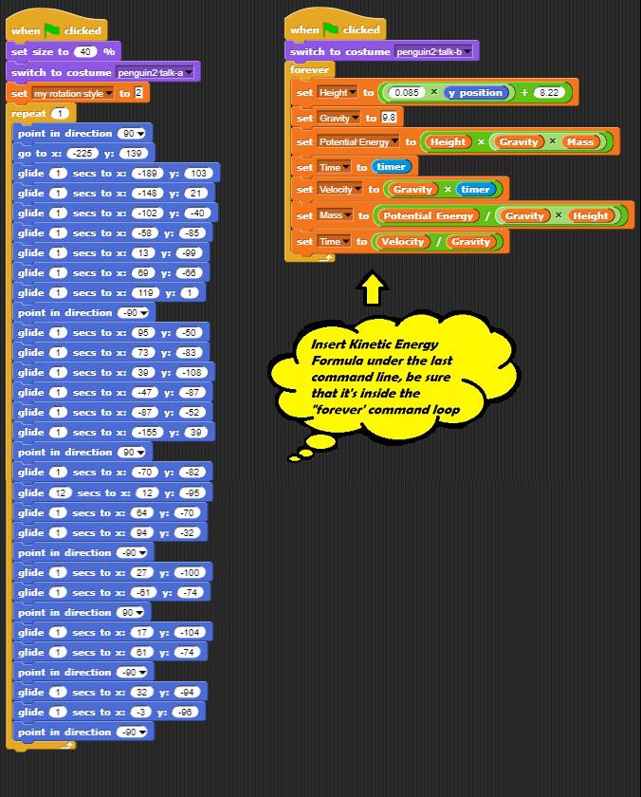

-This illustration is included in the student’s lab activity to show where the students should place the Kinetic Energy formula. Students should enter the fraction as a decimal.

Students will use 1 data command (set Kinetic Energy to) and 3 multiplication operators. (See Figure below)

