Comparing and Ranking Countries

Population sizes have a direct impact on sustainability such as resource distribution, but size is not the only aspect that matters. We have already seen that country populations are important in financial measurements via the debt per citizen. The World Bank actually classifies countries by their income-to-population ratio, specifically the gross national income per capita. There are many other comparisons and rankings of countries. Factors such as life expectancy, religious freedom, human rights, food, water, or oil resources, and technological innovations are included by some and excluded by others, to name just a few possible variables.

According to the Statistics Division, Department of Economic and Social Affairs, of the United Nations Secretariat: "The designations developed and developing are intended for statistical convenience and do not necessarily express a judgment about the stage reached by a particular country or area..." [https://millenniumindicators.un.org/unsd/mi/disclaimer.htm].

- Order the cards from 1 to 16, where 1 is most developed. You may use the internet/neighbors to help you.
- Compare and contrast with your neighbors and comment on similarities and differences in your rankings.

- What factors/variables of “development level” did you use in your rankings?

- Why did Gapminder (where I got the countries from) select these 16 countries to compare, do you think?

- Write down your rankings on the back of this as you’ll be entering them during lab on Monday so that we can collate it and do some (future) whole-class statistical analysis. Also, if you used any external sources to help you make decisions then list those too.

Bangladesh  Southern Asia | Botswana  Southern Africa | Brazil  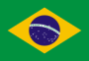  Latin America | China  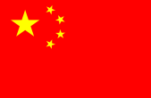  Eastern Asia
Democratic Republic of the Congo  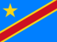  Central Africa | Ethiopia  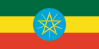  Eastern Africa | India  Southern Asia | Japan  Eastern Asia
Mexico  Latin America | Nigeria  Western Africa | Republic of Korea (South Korea)  Eastern Asia | Russian Federation (Russia)  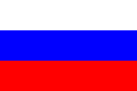  Eastern Europe & Northern Asia
Singapore  South East Asia | South Africa  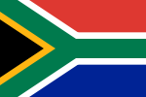  Southern Africa | Ukraine  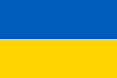  Eastern Europe | United States of America  North America

http://www.gapminder.org/downloads/card-game/

