Project 3: Intrinsic Geometry of Cones
You may work with at most three other people and turn in one per group.

Make a model of a 180-degree cone and use it to answer the following questions. Do not turn in your model. Instead, explain your work and your answers by drawing pictures along with your text explanations.
180-degree cone

- What are the geodesics on the surface of a 180-degree cone? Why? Have you listed all of them? How do you know?
- How many geodesics join two points on a 180-degree cone? Is there always at least one?
- On a 180-degree cone, can a geodesic ever intersect itself? How many times?
- Would your answer to questions 2 change if the angle of the cone varied between 0 < cone angle < 360? Make a cone where you can vary the angle and experiment. If your answer would change, give an example of differing behavior in a specific cone. If not, explain why the behavior would be the same for all such cones.
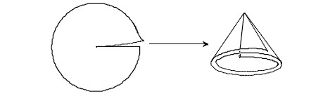
variable angle (0-360 degrees) cone

- Would your answer to question 3 differ if the angle of the cone varied between 0 < cone angle < 360? If so, give an example of differing behavior in a specific cone. If not, explain why the behavior would be the same for all such cones.

Notice that 450-degree cones appear commonly in buildings as so-called "outside corners." Make a model of a 450-degree cone and use it to answer the following questions. Do not turn in your model. Instead, explain your work and your answers by drawing pictures along with your text explanations.

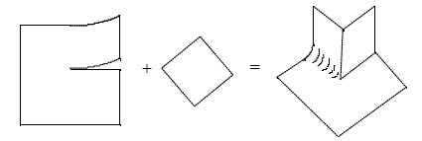
450-degree Cone

- How many geodesics join two points on a 450-degree cone? Is there always at least one?
- On a 450-degree cone, can a geodesic ever intersect itself? How many times?
- On a 450-degree cone, find a point P (other than the cone point) and a geodesic l (not through the cone point) such that there are many geodesics through P that do not intersect l. Sketch a picture and compare this situation to the usual parallel postulate for the plane.

- Exercise 2.1.19. on p. 75 (see the hint in the back of the book too)

Geodesic polar coordinates on an $α$-degree cone can be described intrinsically by y($q$,r)={the point p on the cone, where r is the length of the line segment from p to the cone point and $q$ is the angle along the surface between this segment and a fixed reference ray from the cone point}. These coordinates work for any cone, even those with cone angle larger than 360 degrees.

- Show that if a geodesic is on the cone and p=($β$,d) is the point on that geodesic closest to the cone point, then an arbitrary point y($q$,r) on the geodesic satisfies the equation r=d sec($q$-$β$). Hint: draw a picture that represents this situation in the cone and in the covering plane, and apply trigonometry.

Extra credit An equation for a geodesic on a cone in terms of extrinsic local coordinates is x($q$,r)=(r sin$j$ cos($\frac{2\text{pq}}{α}$), r sin$j$ sin ($\frac{2\text{pq}}{α}$), r cos $j$), where $j$ is the angle between the axis of the cone and a generator of the cone, r=$\sqrt{d^{2}+s^{2}}$, $q$=$β$ +arctan (s/d), and s = arclength along the geodesic. Use the equation for $q$ in order to argue how many times a geodesic on a cone of angle $α$ intersects itself. How does the number of self-intersections depend on the cone angle?

